Programming 6212 POE Mobile Application

2016

Adrian Beukes 15002426

**Content**

Specifications ………………………………………………………………………..2 Purpose Functional Requirements

Test Data ………………………………………………………………………..3

Flow Diagram ………………………………………………………………………..6

Class Diagram ………………………………………………………………………..7

Error Handling …………………………………………………………………….....8

Help ………………………………………………………………………..8

**Specifications:**

Purpose:

The Purpose of this mobile application is to allow for the physician to access all his appointments, to see what time he’s appointments might be so he can better manage his time, and make all appointments.

My program works on a windows mobile application, with the integration of the databases and use that input to give the wanted outcome/reports, in this case, allowing for the physician to view all the appointments on his mobile.

Functional Requirements:

In my mobile application you can do the following:

* Find information about appointments
* Access the information of the database
* Allow for the physician to view this information on his mobile, while he’s on the move.

All of the above was met, with great design and ease of use.

**Test Data**

A few screenshots of my program will follow, with explanation of what’s happening at each stage, as I progress in order to test it:

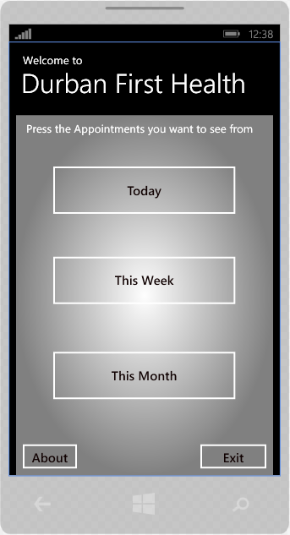

This is the main menu, from which you can select which appointments you would like to view, appointments about today, this week, or as this month, you can also navigate to the about page, which just gives a bit of information on the application, or exit the mobile application on the bottom right.

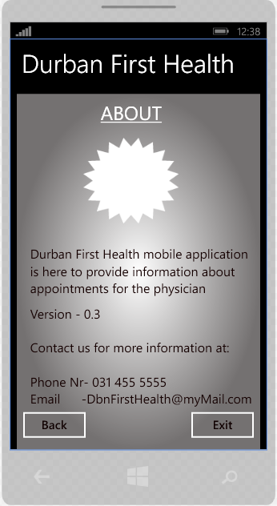

This is the About page, here you can view additional information on the application, namely the version, and contact information, in the case of needing assistance. From here you can exit or navigate back to the main menu again.

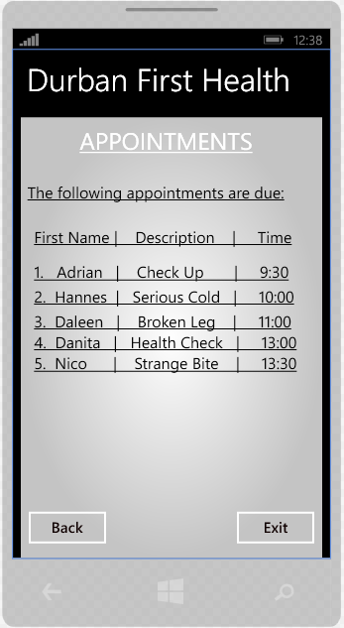

This is the Appointment view, which will give you all the needed information on appointments for the day, namely the patient name, their reason, and at what time their appointment starts, this way you can navigate around there appointments or even use the time in order to prepare for the next patient. You can also navigate back to the main menu or exit the application.

**Flow Diagram:**

Appointments

Main Menu

About Us

**Class Diagram:**

**Durban First Health (web)**

Users (Perma)

Users (Active)

Physician

Admin

Database

**Error Handling:**

For my error handling I added validation to make sure the user enters all needed information.

There’s also a check availability button in the booking page to make sure the date and time is available. This button also allows for the booking button to be enabled after checking if you can book at the specific time.

**Help:**

This is a guide that would take you step for step through the application.

On opening the web application, you will be in the home page, there you can find information on Durban First Health and at the top, and you will find Heading names, which can be used to browse to the other pages, Booking and About Us. There is also a couple of hyperlinks in a different colour, blue, to distinguish itself, and can also be used as an alternative for browsing to the other pages.

In the about us page, you can find even further information, and it tells you a bit more about Durban First Health, as well as give information for contacting us, in order to ask further questions or just to follow us for staying up to date on latest news.

In the booking page, you can fill out your information in order to do a successful booking, please note that all information must be completed, and it will be validated that everything is entered, or tell you exactly, what you still need to enter. Before you can press the booking button, you need to press the check availability button, in order to see if the requested date and time is available for the physician, if it is available, the booking button will be enabled, and you will receive the notification that booking may now be done. Upon successful booking, you will receive another notification to let you know it was a success.